CloneZilla Image Creation Guide:

1. Take the CloneZilla USB Thumbdrive you just made or previously made and insert it into a USB port on the computer that you want to image.
Specific notes: If you are imaging or restoring the simulators, make sure to remove the DisplayPort dummy plug (Small dongle plugged into the video card) before trying to boot off the USB drive, otherwise you will get no video output. MAKE SURE TO PLUG IT BACK IN TO THE EXACT PORT WHERE IT WAS on the video card BEFORE BOOTING the exhibit normally.

2. Boot off the USB drive. This is a wildly different process for every computer, depending on who manufactured the PC. The gist of this is that you want to start with the computer off and the USB drive in the computer.
When the computer starts, you will need to repeatedly press the key to select the boot device option menu. Unfortunately this is not standardized between manufacturers, common ones are F10, F9, F12, or Delete.
Please refer to this:
https://youtu.be/wH9q3KSISvQ
or this (If the computer has a graphical bios):
https://youtu.be/BKVShiMUePc?t=67
for some assistance, if you are having trouble.

Note: Some PCs do better on USB 3 ports vs USB 2. For other PCs, it can be the opposite. Try moving the bootable drive to different USB ports if you are having trouble, especially between black and blue color ports.
Also, sometimes wireless keyboards do not initialize in time to let you get into the BIOS or boot menu. Try using a wired keyboard if you have trouble.

3. Once succesfully booted off the USB drive, you should see this screen:
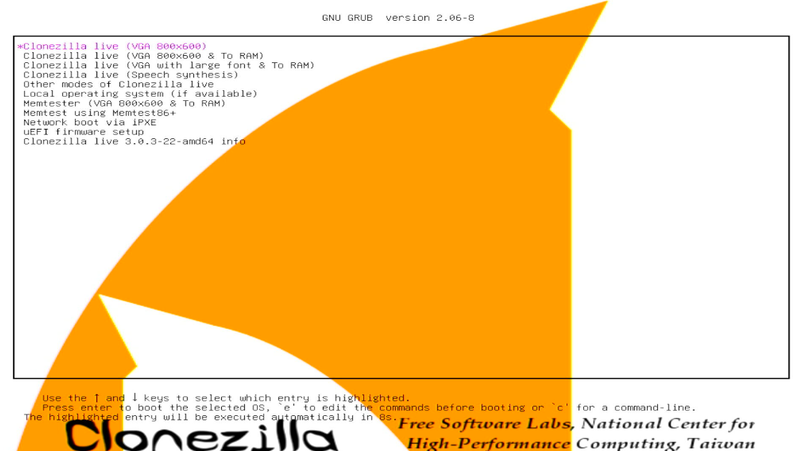
4. Pick the first option. (Press enter)
You can then press enter for all the default options until you get to this screen:
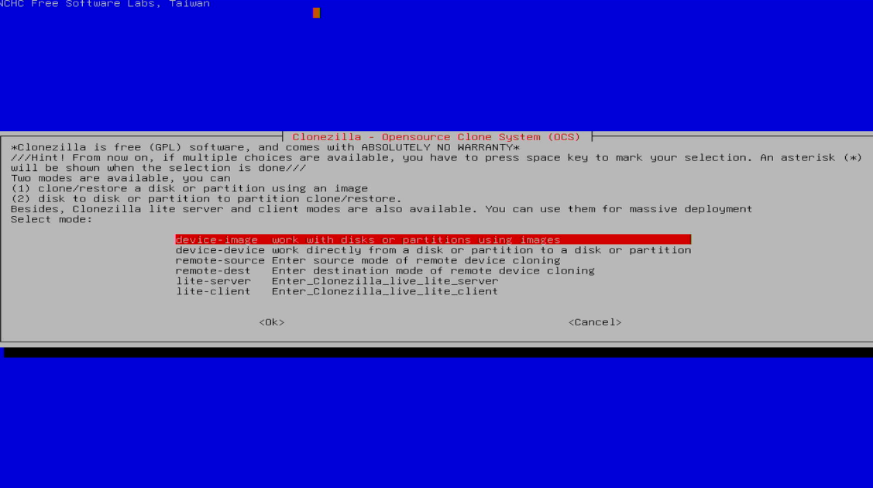
5. At this point, plug in the EXHIBITS BACKUPS External-USB Drive. For optimal speed, plug it into a blue port (USB 3) although it will work on any USB port.
6. choose device-image
7. You should see the below message. Since you already inserted the EXHIBITS BACKUP drive, you can just hit enter.
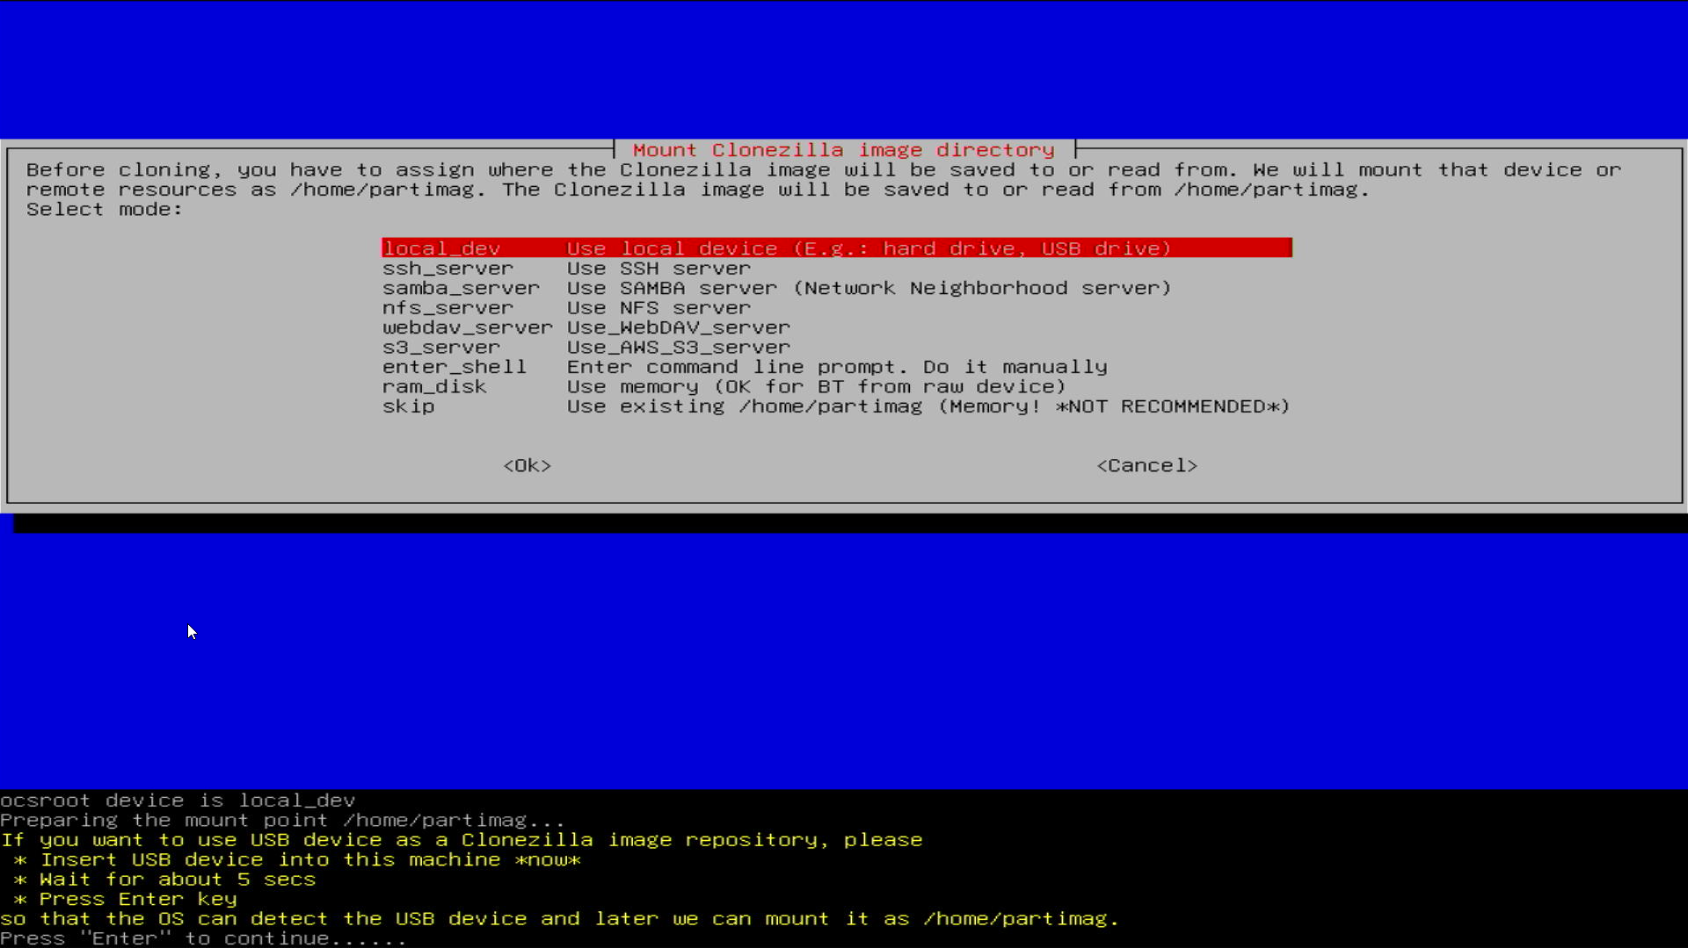
You should then see this screen:

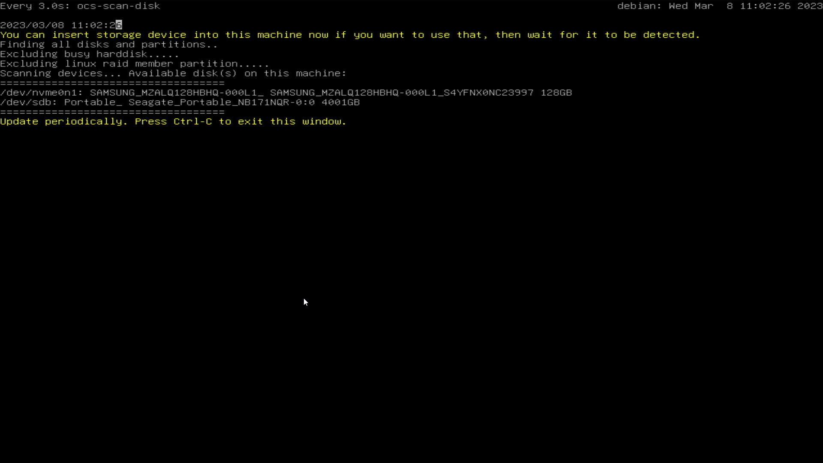
8. Press Ctrl + C
9. Once you get to this screen:
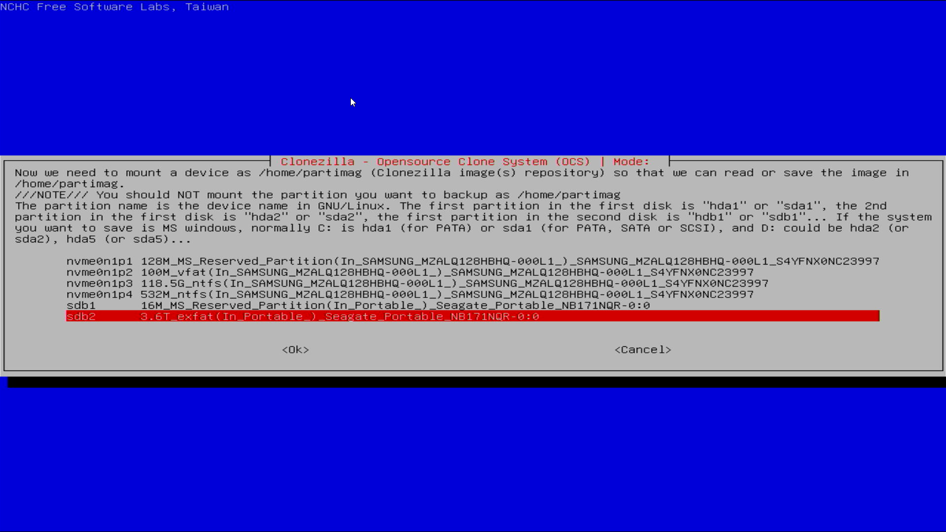
You will need to choose the EXHIBITS BACKUP USB portable hard drive. Be careful! This may not always be sdb2 or even the last entry. What you’re looking for is:
- It should start with 3.6T, this refers to the fact that the drive is 4TB.
- It should say exfat, the partition type
- It should say SEAGATE PORTABLE or something very similar.
Once you’ve found an entry that matches all of the above, select it and hit enter.
10. On the next screen choose no-fsck
11. On this screen:
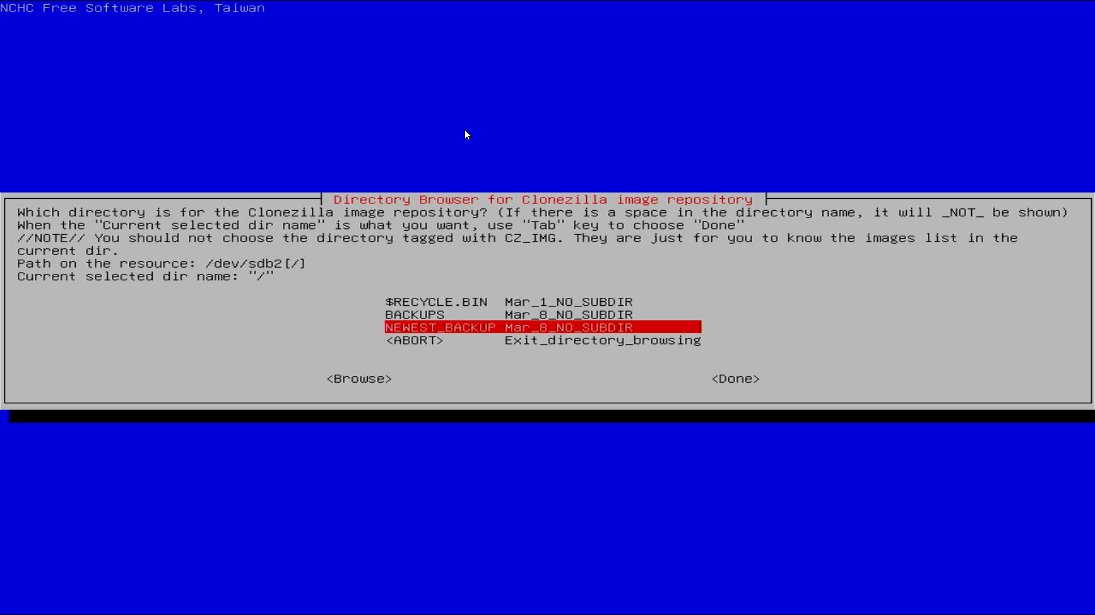
Choose NEWEST_BACKUP folder.
12. You should now see this screen:
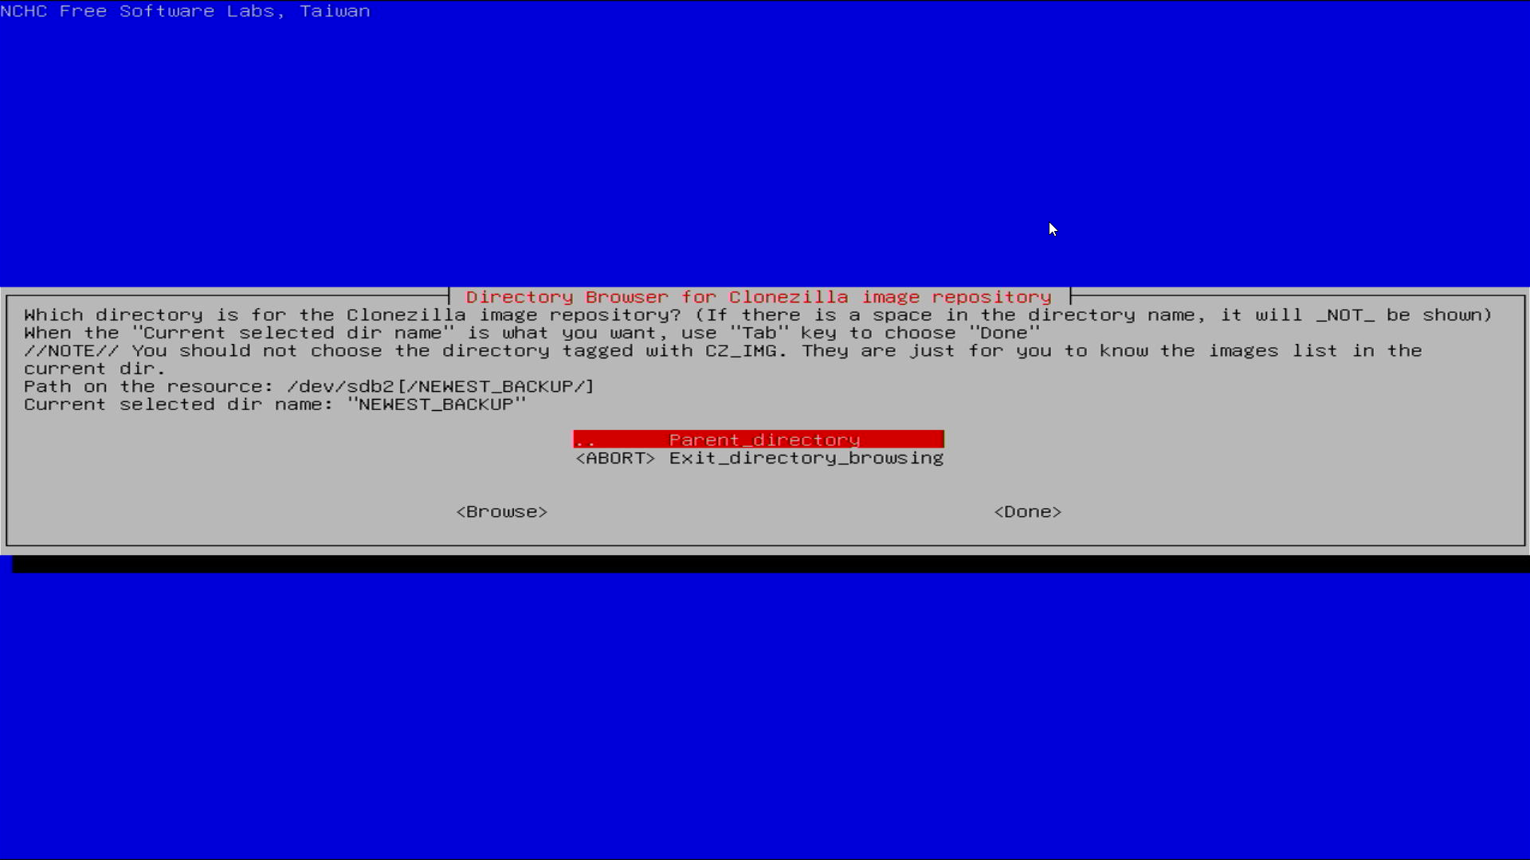
Which means you are in the NEWEST_BACKUP folder on the portable hard drive. Choose done, and you should see this message:
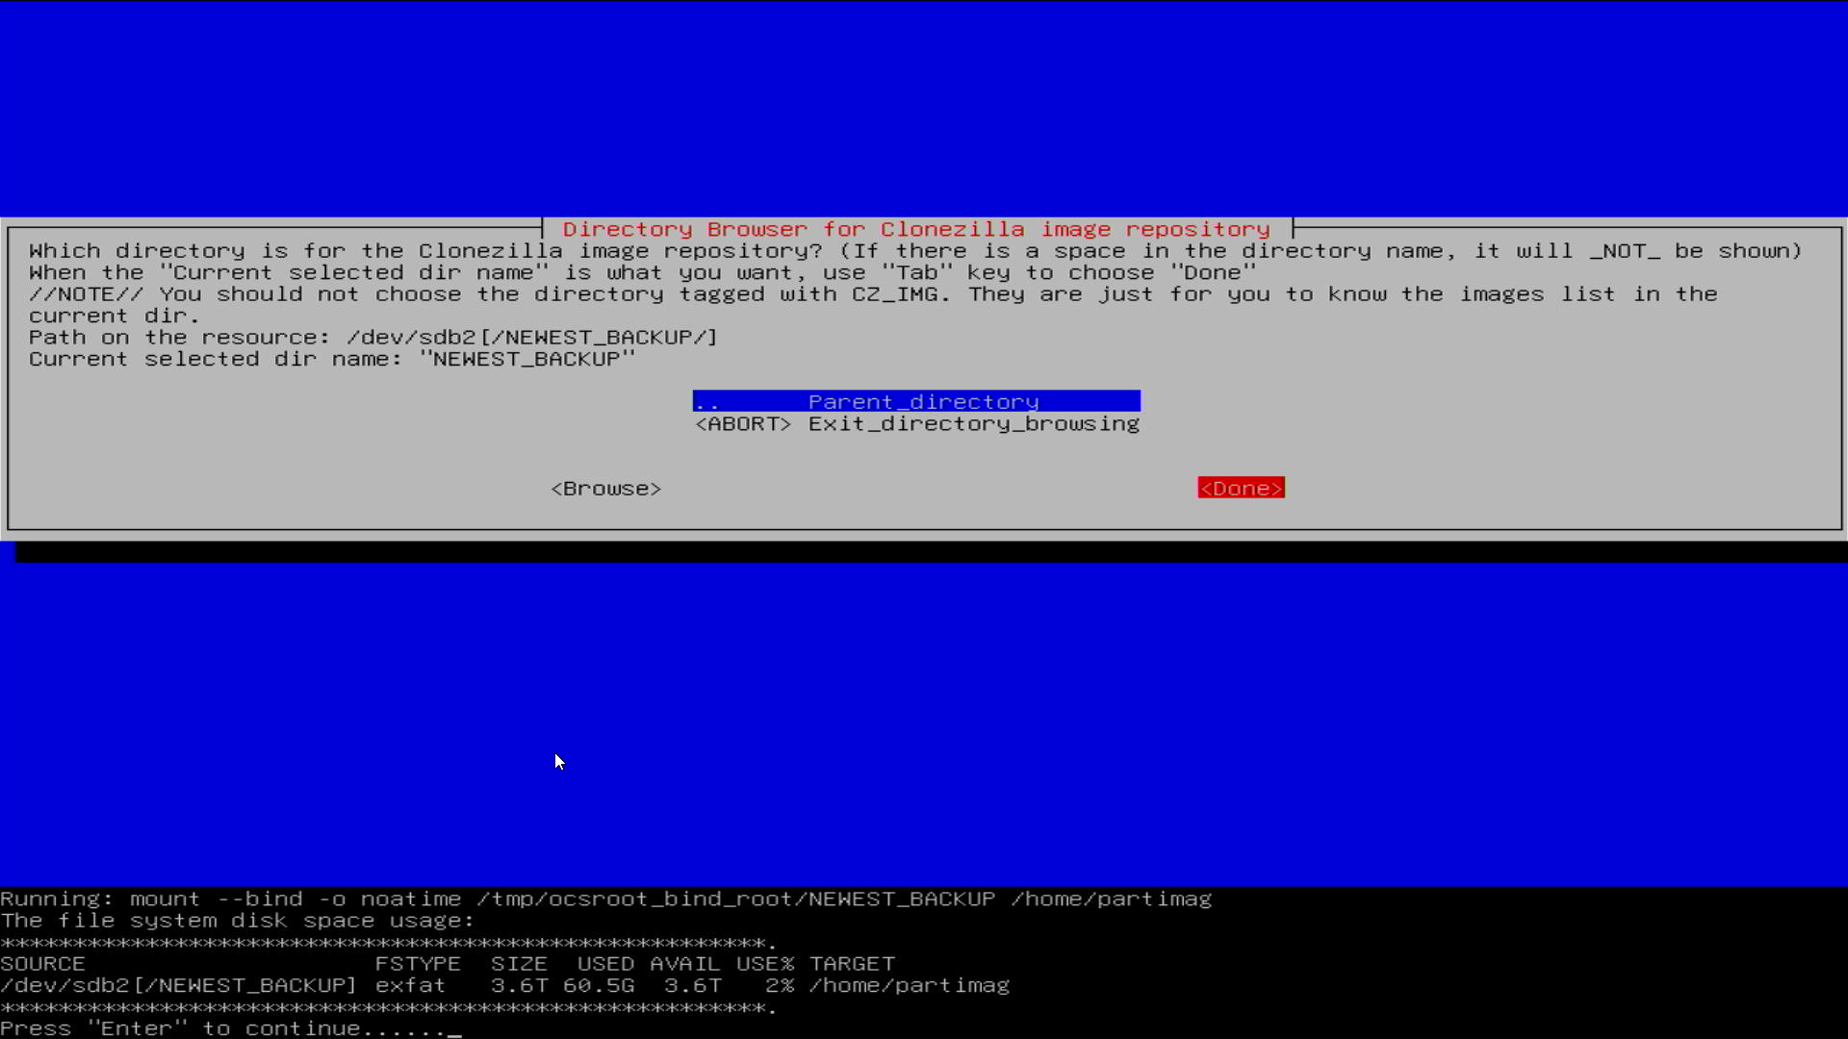
Press Enter.
13. On the next screen, choose the “Beginner” option.
14. Choose “savedisk”
15. On the next screen, name your backup. Name it something obvious related to the exhibit name. I do not know if you can have spaces. I would suggest not having spaces until tested.
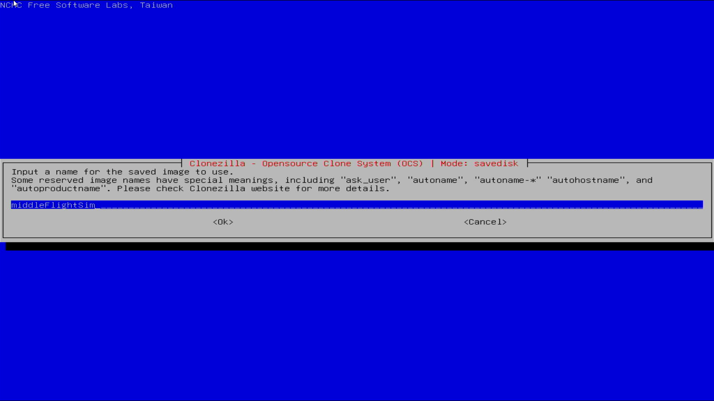
16. Press enter
17. You should see the selection screen for internal hard disks to image. Most exhibits should only have one option. If there is more than one, you will need to repeat this process and make multiple images.
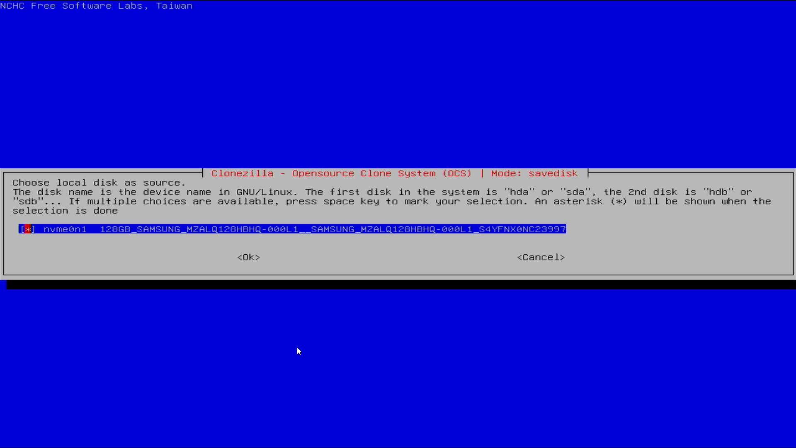
18. Once you have selected which internal disk to image to the portable HDD, press enter.
19. Choose -z9p
20. Choose -sfsck (skip)
21. Select “Yes, check the saved image”
22. Select -senc (Not to encrypt)
23. Choose -p poweroff, (Although you can leave the computer on, but make sure to turn it off before removing the USB HDD and thumbdrive, if you do so.)
24. You should then see this message:
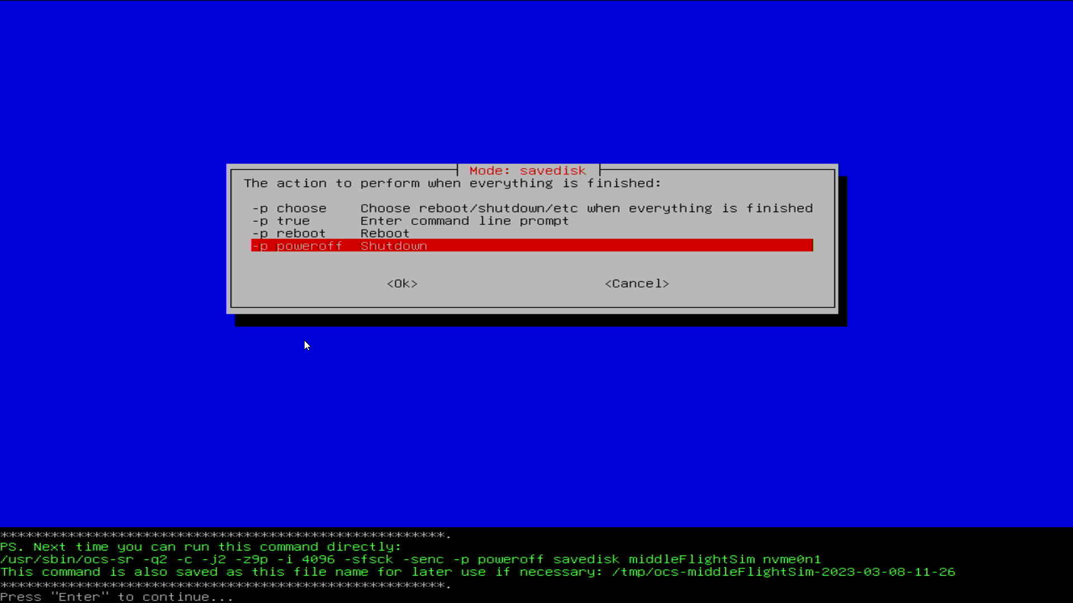
and this means the backup is about to start! Press enter to start it!

You will get a confirmation message similar to this:

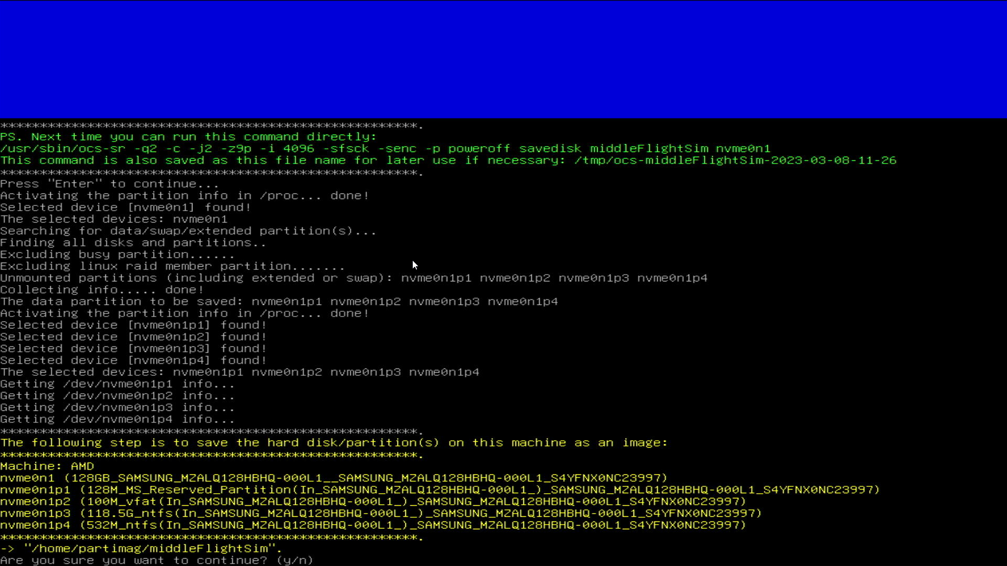
Press y on your keyboard and then enter to start the imaging process!
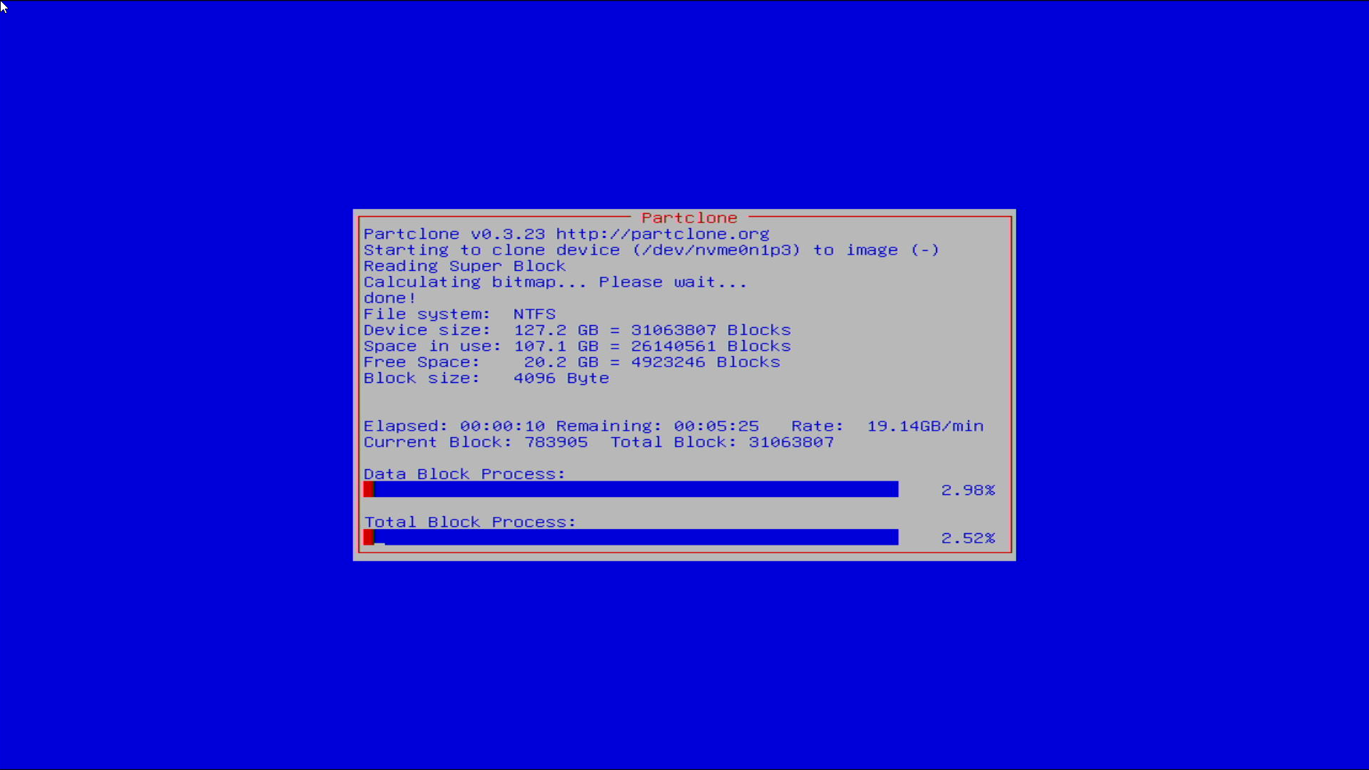
As the backup progresses, you will see a screen similar to this for each partition on the internal drive of the exhibit computer you are backing up. Some will be very fast. Some will take a while.
Once it’s done cloning the internal drive, you should see it switch to verifying the image:
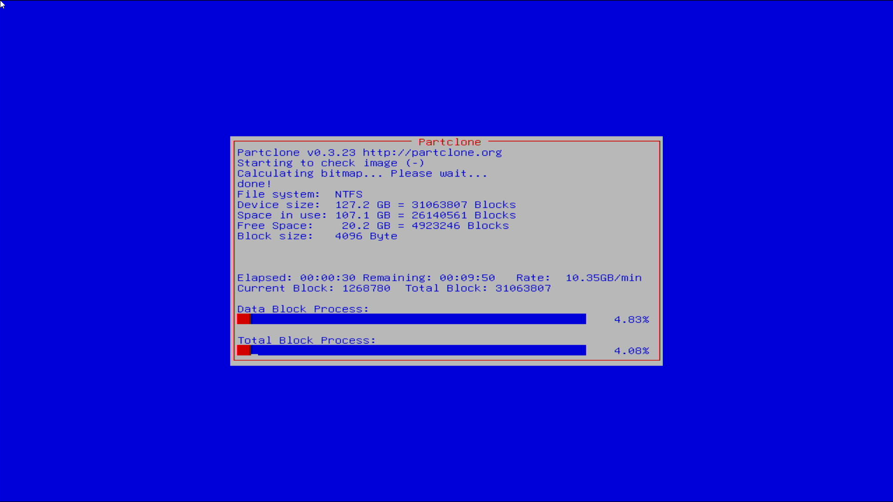
Once it is finished checking the image:

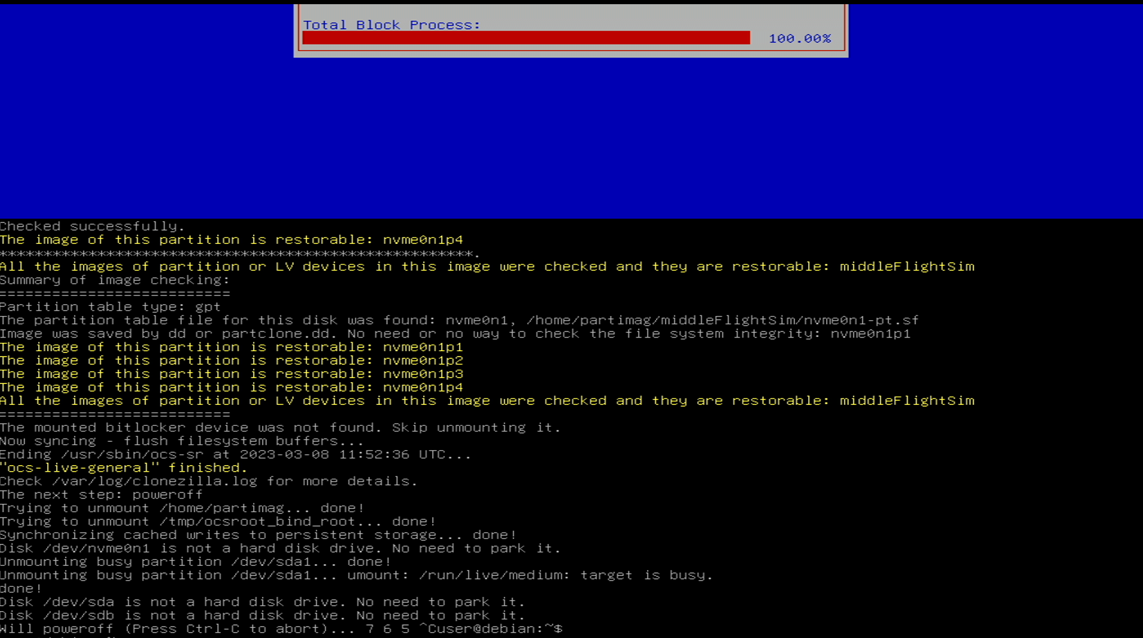
(I have aborted it to save the screen, yours will simply shut down unless there is an error.)

25. Turn off the exhibit computer you were backing up if it is still on.

26. Remove the EXHIBITS BACKUPS HDD and the thumbdrive.

27. Put the EXHIBITS BACKUPS HDD into a working computer.

28. Open the NEWEST_BACKUP folder on the EXHIBITS BACKUPS HDD

29. Right click the backup folder you made, and click properties

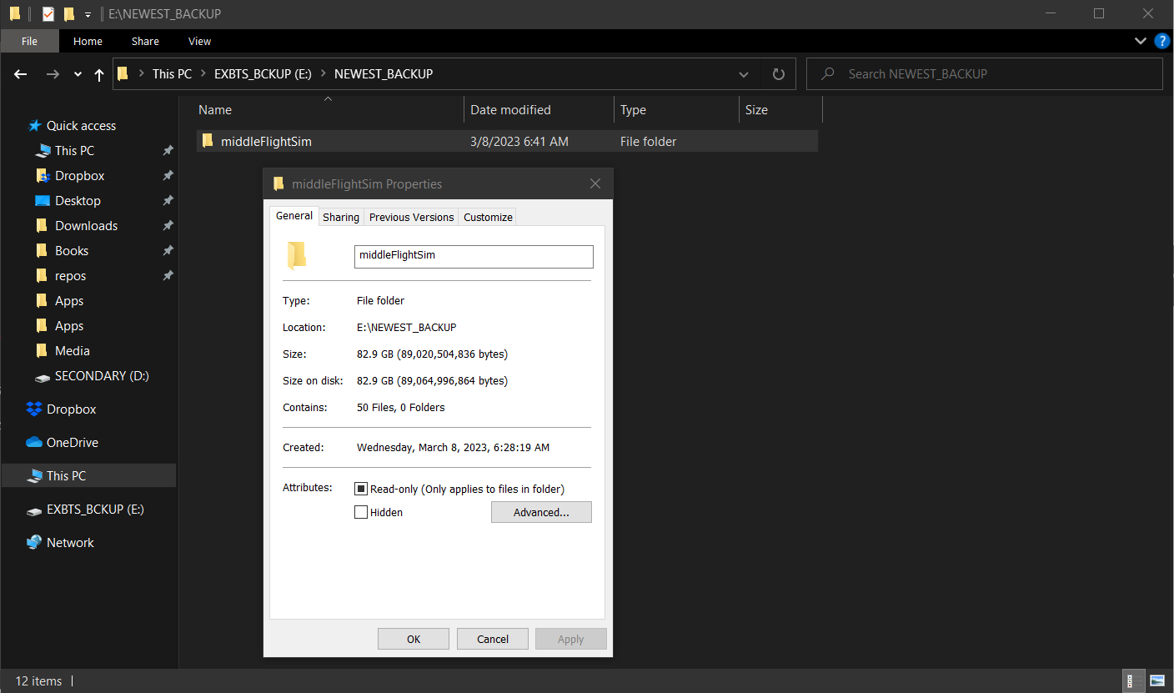
Make sure it’s a reasonable size. If it’s less than about 30gb, something may have gone wrong.

30. Press ok

31. Move the new backup out of NEWEST_BACKUP into the appropriate folder in BACKUPS

32. Use “Safely remove hardware” in Windows to eject the EXHIBITS BACKUPS HDD

33. Return the EXHIBITS BACKUPS HDD to the exhibits department manager.

